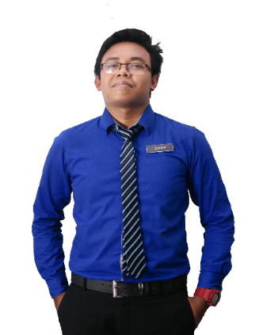

# Gender

# Age

# Marital Status

# Race

# Religion

# Date of Birth

# Nationality

# : Female

# : 29 Years Old

# : Married

# : Malay

# : Islam

# : 18 June 1991

# : Malaysian

# Phone

# +6019-3139xxx

# Email

# resumecreative@gmail.com

# Address

# Kampung Padang Pulai, 09300 Kuala Ketil, Kedah

# PERSONAL DETAILS

# CONTACT

# PERSONAL SKILLS

# Management

# Communication

Leadership

# Teamwork

# SKILLS

# Microsoft P.Point

# Microsoft Excel

# Microsoft Word

Dec 2014 - Jan 2015

Feb 2015 - June 2015

2007 - 2008

# REFERENCES

**PUAN NOR HAZWANI BINTI WAHAB**

Chef Kitchen

Kinrara Resort Puchong Selangor

Phone: +6013-87963xxx

**PUAN ROSHIAH BINTI ARSHAD**

PIC

Measatt Broadcast Sdn Bhd

Phone: +6017-6038xxx

* Excellent written and verbal communication skills.
* Strong problem-solving and analytical skills.
* Ability to work independently in a fast-paced environment.
* Strong interpersonal skills and positive work ethic.
* Able to coordinate several tasks simultaneously.

# STRENGTHS

# ACHIEVEMENT / INVOLVEMENT

* Participant of Interbankers Basis of Banking (2011)
* Participant of Kursus Keusahawanan oleh Agro Bank (2010)
* Participant of Kursus Bina Negara by Biro Tata Negera JPM (2009)
* Treasurer of Traditional Game (2008)
* Committee Member of Kadet Bomba (2008)
* Assistant Secretary of Kelab Pelaburan Bijak (2007-2008)
* Assistant Class Monitors (2008)

**KINRARA RESORT, PUCHONG**

Commiss

Data Entry

**MEASATT BROADCAST SDN BHD, BANGSAR SOUTH**

# WORK EXPERIENCE

2004 - 2006

1998 - 2003

**SEKOLAH KEB. PAYA BESAR, KUALA KETIL**

Ujian Pencapaian Sekolah Rendah (UPSR)

**SEKOLAH MEN. KEB. TANJUNG PUTERI, KUALA KETIL**

Penilaian Menengah Rendah (PMR)

Sijil Pelajaran Malaysia (SPM)

# EDUCATION

**SEKOLAH MEN. KEB. TANJUNG PUTERI, KUALA KETIL**

Dedicated and self-motivated individual seeking for a challenging working opportunity in an organization to utilize my personal capability and creativity that would allow me to develop my skills while contributing to the organizational goals.

# LANGUAGES

English

# Malay

MUHAMAD SOLEH HUDIN BIN SHAM

SOLEH